DEFINING SPECIFIC SUITES OF DIAGNOSTIC CHARACTERISTICS OF SOME REDUCED INTRUSION-RELATED GOLD SYSTEMS IN EASTERN AUSTRALIA

Michael R. Leu

Sovereign Gold Company Limited

Keywords: Intrusion-Related Gold System (IRGS), Reduced Intrusion-Related Gold System (RIRGS), New England Orogen, Rocky River-Uralla Goldfield (RRUG), Lachlan Orogen, Hobbs Pipe, Mount Adrah

Abstract

Intrusion-Related Gold Systems (IRGS) include a diverse variety of gold-only deposits with direct spatial and temporal links to intermediate to felsic intrusions and their exsolved fluids. Some can be developed within intrusions (e.g., Hobbs Pipe, Mount Adrah), whilst others can range through proximal to distal from a causative intrusive source. Characterisation of IRGS has developed substantially from research into gold systems in the Tintina Gold Province (TGP) of Alaska and Yukon. Thompson and Newberry (2000) defined Reduced IRGS (RIRGS) to differentiate systems associated with magmas of reduced oxidation state from those linked to chalcophile oxidized magmas (Hart 2005).

Sovereign Gold Company Limited is currently researching two RIRGS in New South Wales viz. the Rocky River-Uralla RIRGS in the New England Orogen and the Hobbs Pipe RIRGS at Mount Adrah in the Lachlan Orogen. The large mineralised system in Rocky River-Uralla Goldfield (RRUG) has multiple characteristics distinctly diagnostic of well-studied RIRGS. The Hobbs Pipe RIRGS will only be briefly discussed herein as research is ongoing.

Introduction

Hobbs Pipe, Mount Adrah

The Hobbs Pipe (Mount Adrah) is located on the Gilmore Fault Zone (Gilmore Suture) 18km northwest of the historic gold mining town of Adelong (411km southwest of Sydney). It has a mineral resource estimate of 770,000oz of gold (440,000oz Indicated; 330,000oz Inferred) within a total mineral resource estimate of 20.5Mt at 1.1g/t gold, at various cut-off grades. It is a transversely sub-elliptical, vertical stock composed of weakly oxidised altered monzodiorite that is 180m x 160m in diameter at 500m vertically below surface. Drilling has confirmed continuous and remarkably homogenous gold mineralisation from surface to a vertical depth of at least 886m. Ongoing research is defining diagnostic characteristics that support the potential to identify repetitions along the Gilmore Fault Zone and associated splays.

Diamond drill hole GHD001 (vertical) sampled mineralisation from surface until it exited Hobbs Pipe at 886m downhole. The average gold and multielement assays for 2m composite samples over this interval are:
- 1.17g/t Au from 0.0-886m, including 1.3g/t Au from 0.0-720m; 1.4g/t Au from 0.0-400m; 104m @ 1.6g/t Au from 292-396m; 50m @ 1.9g/t Au from 300-350m; 96m @ 1.6g/t Au from 622-718m.
- 0.0-886m: Ag 0.59g/t, As 4,801g/t, Bi 0.095g/t, Mo 5.78g/t, Sn 3.21g/t, W 6.08g/t, Sb 14.69g/t, Te mostly <0/05g/t, Na 2.86%, K 2.21%, Pb 20.32g/t, Zn 55.12g/t, Cu 29.94g/t, Nb 40.90g/t, Th 23.09g/t, U 7.49g/t, Y 38.1g/t.

The Hobbs Pipe has undergone pervasive alteration (phyllic and lesser propylitic) with the dominant sulphide phases being arsenopyrite and pyrite (total <5%) associated with <10% free gold. It exhibits the enigmatic RIRGS characteristics of negligible quantities of the typically ubiquitous felsic magmatic fluid components of Bi and Mo. Petrochemical work by Wormald and Price (in Hee, 2005) indicated that mineralisation is directly linked to relatively deep level passive crystallization of the magma. Drill hole data and surface mapping confirms the lack external brecciation and multidirectional stockwork in the enclosing hornfelsed metasediments. Hart (2005) notes volatiles are easily dissolved in felsic melts under the higher pressures of deep emplacement (5-9km, RIRGS) and that this inhibits rapid fluid exsolution and the explosive release of pressure that develops the stockworks and breccias typical of more shallowly emplaced porphyry deposits. The Hobbs Pipe provides the opportunity to study an RIRGS that crystallised under deep confining pressure in a setting most parsimoniously comprising the depths of a back-arc location. Based on the above and the diagnostic tectonic setting characteristics of RIRGS detailed herein, the mineralisation within the Hobbs Pipe supports the interpretation of Quinn, Percival, Glen and Xiao (2014) that at least this section of the Macquarie Volcanic Belt occupied a back-arc setting in the Late Silurian and Early Devonian.

Rocky River-Uralla Goldfield

The Rocky River-Uralla Goldfield has a plethora of characteristics distinctly diagnostic of RIRGS in the TGP. Sovereign Gold’s predecessor acquired Exploration Licences over the RRUG to study the origin of the Tertiary deep leads and Quaternary to Recent placer deposits (Leu et al. 2008). Fieldwork identified that gold in some areas was mined directly from eluvial deposits developed from decomposed Uralla Granodiorite, indicating a magmatic source. An airborne geophysical survey undertaken by the Geological Survey of N. S. W. (Brown 2003) established that most of the historical hard rock gold mines may have a shared origin, as many are aligned along major structures. Robertson (2010) characterised the Wilsons Creek gold mine within the RRUG as representative of IRGS mineralisation. The system is yet to yield a large economic gold deposit, however the confirmation of broad ranging RIRGS features combined with numerous undrilled targets supports potential for mineable gold endowment.

A diverse and substantial body of data (numerous publications, postgraduate and Honours theses, etc.) have been generated on the geology of the RRUG region (especially in relation to batholiths and associated plutons) due its proximity to the both University of New England and the Armidale Division of the Geological Survey of N. S. W. This vast data base, combined with recent research by Sovereign Gold, has substantially assisted this synthesis.

The township of Uralla and its hinterland to the west and northwest forms the focus of the RRUG. Uralla is located 21km southwest of Armidale and 451km northnorthwest of Sydney, N.S.W. Production from just deep lead deposits during the first five years of the Goldfield amounted to 3,700kg gold, representing almost 2% of the total world production in that period (Mackay, 1953). ‘The discovery of payable gold at this locality took place in the year 1856, although as early as 1852 the Rev. W. B. Clarke had noted the presence of alluvial gold along the banks of the Rocky River. Available production records indicate that the Rocky River and Uralla Goldfield yielded 5,192.71kg of gold during the period 1858-1967. As such, it rates as one of the most productive fields of the New England district. Almost the whole of this amount would have been derived from alluvial sources, both recent and deep lead’ (Markham 1975). The RRUG essentially slipped into obscurity after the majority of the rich placer deposits were mined-out. Brown (2003) noted gold exploration has been hampered by a lack of understanding of mineralisation controls and conceptual models. The system hosts at least 19 separate small hard rock gold mines/prospects and numerous geochemical anomalies that had never been tested by drilling prior to exploration by Sovereign Gold. This research is the first attempt at an integrated interpretation of geological, geophysical, petrophysical, geochemical and metallogenic data to determine the type, size and intensity of this gold-bearing mineral system.

A holistic approach is essential to differentiate unrelated systems that have parts in common convergently developed through disparate processes. A suite of characteristics has been defined that collectively differentiate the magmatic fluid source for RIRGS mineralisation from the metamorphic fluids of orogenic gold deposits.

The RRUG has multiple features, detailed herein, that define the geological setting and mineralisation controls of this RIRGS including (after Lang and Baker 2001, Blevin 2005, Hart 2005 and 2007) the presence of weakly reduced to moderately oxidised, intermediate to felsic fractionated magmatism emplaced in a tectonic setting (back-arc, extensional) well inboard of a convergent plate boundary.

RIRGS have crustal-scale vertical zonation, with epizonal occurrences forming at shallower levels compatible with emplacement at low pressures and temperatures. They can occur as sheeted quartz-sulphide veins and matrix-filling breccias. The sulphide assemblage is dominated by arsenopyrite, pyrite and late stibnite associated with phyllic alteration (Hart, 2007). Many of the gold-bearing deposits in the Rocky River-Uralla RIRGS are epizonal (Wilsons Creek mine, Hudsons-McCrossins mine, Bannaweera Structures No.1 and 2, Goldsworth mine, Gracies mine, Little Gracies mine, Hudsons prospect, Vickers prospect; Figure 1) and this indicates the bulk of the system is preserved at depth and it is highly probable some of these structures will be conduits directly linked to a causative pluton. Various late stage phases of fractionated mineralised felsic dykes and exsolved fluids have also invaded structures within metasediments or earlier dykes of the Regional Felsic Dyke Swarm (RFDS), e.g., mineralisation at Martins Shaft.

Coinciding anomalies (airborne/ground geophysics supported by soil geochemistry and mapping of geology, structure and alteration) effectively define drill targets e.g., airborne magnetics and radiometrics have revealed extensive potassic alteration coupled with potential small concealed plutons emplaced within the Uralla Granodiorite (Figure 2). Jogged, bifurcating and intersecting structures can generate wider zones for mineralisation.

An airborne magnetic and radiometric geophysical survey, at a 60m elevation along 50m close-spaced survey lines (5,008 line kms), delineated a gold mineralised system that extends at least 11km from north to south and 6.5km from east to west. It is associated with strong structural control, minor plutons and felsic dykes. A substantial proportion of the hard rock gold mineralisation is hosted by, and strikes parallel with, northeast trending structures that have been traced over distances of hundreds of metres to several kilometres (Figures 1, 2 and 6). These structures and the accompanying gold mineralisation comprise the last tectonic and magmatic events (disregarding Tertiary volcanics) mapped within the RRUG. Many are not controlled by geology and cut through metasediments, the Uralla Granodiorite and the late stage northwest trending RFDS. Mineralisation is hosted by phyllic alteration (quartz-sericite-sulphides) associated with sheeted quartz-sulphide veins and dykes (felsic and lesser lamprophyric). A number of other gold occurrences were developed near the fault-bounded eastern contact of the Sandon Beds with minor plutons and a felsic dyke. The series of northeast trending structures developed in extensional event during the late Permian.

Potential Targets

Shallow bulk mineable sheeted vein systems (1-2g/t Au), auriferous felsic dykes, the preserved carapace of a pluton beneath mineralised hornfelsed metasediments, concealed mineralised small plutons (<500m diameter), hypogene gold within late stage northeast trending structures and along pluton-metasediment contacts. Target model of several satellite mineralised zones (resource blocks) of up to 100,000 ounces.

Drilling has confirmed gold mineralisation in altered felsic dykes (Martins Shaft, continuous from surface to 219m depth), along several northeast trending structures for up to 1.55km and in sheeted vein systems in the Uralla Granodiorite.

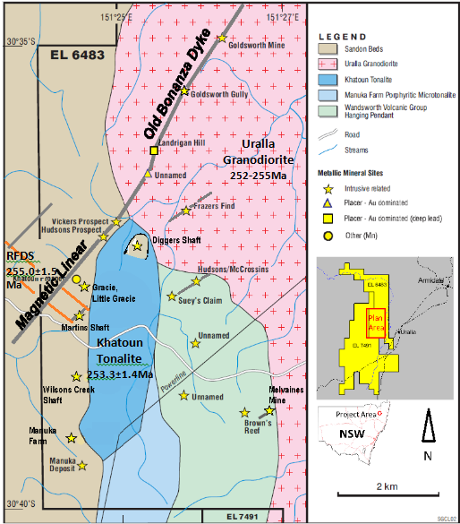

Figure 1. Historic gold mines plotted on geology (and geophysics, Figure 2) define clear structural controls and common links between the mineralisation, indicating they are parts of a larger system. Many mines plot on the northeast trending magnetic linear (“Old Bonanza Dyke”). A ~northsouth trending series of mines has developed immediately west of the contacts of small elongate plutons (Khatoun Tonalite and Manuka Farm Porphyritic Microtonalite) with the Sandon Beds. Other mines are situated within the roof pendants of the Wandsworth Volcanic Group and Sandon Beds.

Status of Diagnostic RIRGS Characteristics Identified in the Rocky River-Uralla Goldfield Based on Criteria Defined or Compiled by Lang and Baker 2001, Blevin 2005, Hart 2005 and 2007. Two new regional characteristics are proposed that link the Rocky River-Uralla RIRGS with RIRGS of the TGP.

Key ‘generic’ RIRGS characteristics are summarised below and then, in the sections following, each is validated to varying extents with data specifically related to the RRUG RIRGS.

The characteristics are subdivided into Regional Scale, System Scale and Deposit Scale.

REGIONAL SCALE CHARACTERISTICS
- Orogenic belts, extensional back-arc environments (Blevin 2005); a tectonic setting of continental magmatism well-inboard of inferred or recognised convergent plate boundaries (Lang and Baker 2001). Reduced IRGS deposits are best developed in intrusions that were emplaced into ancient continental margins behind accretionary or collisional orogens and subduction-related magmatic arcs (Hart 2005).
- Presence of weakly reduced to moderately oxidised, intermediate to felsic fractionated I-type magmatism, have low Fe contents (IRGS, Blevin 2005). Redox State: Reduced IRGS are associated with felsic, ilmenite-series plutons that lack magnetite and have low ferric:ferrous ratios of <0.3 (Hart 2005); plutons can have both I and S-type characteristics (Hart 2007).
- Granites with historically recorded molybdenite occurrences associated in areas of known W-Mo and W-Sn mineralisation (Blevin 2005). A location in magmatic provinces best or formerly known for tungsten and/or tin deposits (Hart 2005).
- There may be a regional association with orogenic lode Au deposits (Blevin 2005).
- Gold is associated with late stage plutons and dykes derived from melts generated over relatively short intervals of geologic time. They are amongst the final products of much longer time intervals of regional magmatism (Leu 2015).
- Gold mineralisation is coeval with a late stage regional extensional event (Leu 2015).

SYSTEM SCALE CHARACTERISTICS
- Historically recorded association of hard rock Au deposits in granites and their aureoles, or alluvial placers apparently shed from granites (Blevin 2005).
- Magmatic origin for mineralisation.
- Granites are equigranular to porphyritic and have subequal quartz, plagioclase and alkali feldspar with minor, usually biotite>amphibole, and minor apatite (Blevin 2005). Biotite>hornblende> pyroxene quartz monzonites that have mixed with volatile-rich lamprophyric melts (Hart 2007).
- Geochemical Characteristics.
- Two types of igneous associations are apparent: intermediate (i.e. granodiorite) I-types (SiO₂ = 60 to 70%), and felsic (SiO₂ = 70 to 76%), high-K, I-type and fractionated. The latter are enriched in incompatible elements (Y, REE, Th, U, Nb) and depleted in compatible elements (Ti, P, Sr, Fe, Mg, Ni, Cr), (Blevin 2005).
- RIRGS: Metaluminous, subalkalic intrusions of intermediate to felsic compositions that lie near the boundary between ilmenite and magnetite series (Hart 2005). IRGD are metaluminous to weakly peraluminous (A/CNK = 1.0 to 1.1) in the more felsic examples (Blevin 2005).
- Geophysical Characteristics (also includes some deposit scale data).
- Felsic, ilmenite-series plutons, low to nil magnetite contents, have low magnetic susceptibilities and flat aeromagnetic responses (Blevin 2005, Hart 2005).
- Highly fractionated granites will have elevated K and U and, in the case of metaluminous I-types, will also have high Th. These will appear white on composite K-Th-U radiometric images (Blevin 2005).
- Timing: Intrusion-related deposits are coeval (± 2 m.y.) with their associated, causative pluton (Hart et al. 2004b, Hart 2005).
- Elongate plutons reflect structural controls on pluton emplacement and indicate a dominant extensional direction that may be important for localizing later mineralization (Hart 2005).
- Pluton Features: Evidence of rapid fractionation and fluid exsolution indicative of volatile saturation during crystallisation at mid to high crustal levels (Blevin 2005, Hart 2005).

DEPOSIT SCALE CHARACTERISTICS
- Diagnostics geochemical characteristics.
- Pathfinder and source locating elements.
- Metal assemblages are gold-dominant with anomalous Bi, W, As, Te and/or Sb, and typically have non-economic base metal concentrations (Hart 2007).
- A low sulphide mineral content, mostly <5 vol%, with a reduced ore mineral assemblage that typically comprises arsenopyrite, pyrrhotite and pyrite and lacks magnetite or hematite (Hart 2005).
- The gold is fine-grained (Blevin 2005).
- Alteration.
- Deposit style, size, morphology and architecture.
- Some Specific Deposit Styles of the Rocky River-Uralla RIRGS: Martins Shaft, Goldsworth Mine, Frasers Find, The Bannaweera Structures, Melvaines Mine.

REGIONAL SCALE CHARACTERISTICS

Orogenic belts, extensional back-arc environments (Blevin 2005); a tectonic setting of continental magmatism well-inboard of inferred or recognised convergent plate boundaries (Lang and Baker 2001). Reduced IRGS deposits are best developed in intrusions that were emplaced into ancient continental margins behind accretionary or collisional orogens and subduction-related magmatic arcs (Hart 2005).
Confirmed, Characteristic of the Rocky River-Uralla RIRGS.
- The RRUG occurs within the central portion of the Central Block (or Woolomin-Texas Block) of the southern New England Orogen, inboard from convergent plate boundary. The late Permian plutons (Uralla Granodiorite, Khatoun Tonalite, Manuka Farm Porphyritic Microtonalite), that are the potential source of the auriferous system, were emplaced within the accretionary collisional orogen after regional-scale folding and thrusting (Brown et al. 1992).
- Shaw and Flood (1981) note “The New England Batholith is part of the Upper Palaeozoic New England Fold Belt, with most plutons intruded into the deformed trench-complex metasedimentary rocks in the southeast part of the Fold Belt. The Batholith was emplaced in two major periods of plutonism, the first during the Upper Carboniferous and the second during the Upper Permian and Triassic, with a major phase of metamorphism and deformation including westward overthrusting of the trench-complex sedimentary rocks between the two periods.”
- Phillips et al. 2011 “Slab rollback in the early Permian resulted in the relocation of the New England Orogen into a back-arc setting, which by the late Permian, had been thickened due to the Hunter Bowen Event (Glen, 2005). We attribute the switch in isotopic character from highly depleted (i.e., Clarence River Suite) to evolved (i.e., Moonbi Suite) to crustal thickness before (i.e., thin) and after (i.e., thick) the Hunter Bowen Event. Evidence of renewed mixing between depleted and evolved magmas characterises the formation of the c. 249Ma Uralla Suite (+7-+16ԑHf units), which interestingly, was coeval with renewed orogenic extension”

Presence of weakly reduced to moderately oxidised, intermediate to felsic fractionated I-type magmatism, have low Fe contents (IRGS, Blevin 2005). Redox State: Reduced IRGS are associated with felsic, ilmenite-series plutons that lack magnetite and have low ferric:ferrous ratios of <0.3 (Hart 2005); plutons can have both I and S-type characteristics (Hart 2007).
Confirmed, Characteristic of the Rocky River-Uralla RIRGS.
- Although classified as I-type, the Uralla granites have many characteristics that are transitional between New England Batholith S- and I-type granites (c.f., ilmenite-series granites of Ishihara), including lower redox states (lower Fe₂O₃/FeO; δ¹⁸O typically >9), lower normative diopside and higher initial ⁸⁷Sr/⁸⁶Sr ratios (~0.7046-0.707) indicating the involvement both infracrustal and sedimentary source components. The supersuite can be subdivided into a number of distinct spatially associated geochemical groups (Bryant, Chappell and Blevin 2003).
- Shaw and Flood (1981) note the Uralla Plutonic Suite has δ¹⁸O only just less than 10 and that chemical composition of the Uralla Plutonic Suite shows intermediate I-S type characteristics, and suggest that the source rocks (from which granodiorite was derived, by partial melting) were at an interface region consisting of pelitic sedimentary rocks, and a meta-igneous source region.

Granites with historically recorded molybdenite occurrences associated in areas of known W-Mo and W-Sn mineralisation (Blevin 2005); A location in magmatic provinces best or formerly known for tungsten and/or tin deposits (Hart 2005).
Confirmed, Characteristic of the Rocky River-Uralla RIRGS.
Tin, molybdenum and tungsten, associated with granitic plutons, were mined in the hinterland to the west and north of the RRUG.

The New England Batholith of the southern New England Orogen comprises six main plutonic suites: The Hillgrove Suite, The Bundarra Plutonic Suite, The Clarence River Supersuite, The Moonbi Plutonic Suite, The Uralla Plutonic Suite and leucoadamellites. The hinterland of the Rocky River-Uralla RIRGS hosts several historic tin (some large scale placer occurrences), molybdenum and tungsten mines; the latter two being mostly small scale. The S-type early Permian Bundarra Plutonic Suite hosts several small cassiterite deposits.
The deposits associated with I-type, post orogenic granitoids are (from Brown et al. 1992):
- The Uralla Plutonic Suite: Tingha Adamellite: Associated mineralisation includes Sn and Mo; Gwydir River Adamellite: Associated mineralisation includes Sn, Mo (molybdenite pipe, Perrins prospect (MAO355); Honeysuckle Creek Leucoadamellite: Associated mineralisation includes Mo.
- The Bundarra Plutonic Suite: Associated mineralisation includes Sn (The Glen deposits MAO320-323, End of the World Mine MAO418, The Giants Den Mine MAO545 plus others).
- The Moonbi Plutonic Suite: Associated mineralisation includes Sn and Mo. Attunga Creek Adamellite hosts several small vein-type molybdenite deposits that include W-Mo bearing veins and skarn deposits. Moonbi Adamellite hosts three small Mo-W deposits.
- The leucoadamellites: Associated mineralisation includes Sn, Mo, W, and Bi. Gilgai Granite hosts several rich tin fields (Tingha, Copeton, Elsmore; collectively once a major tin producing region), as well as occurrences of Mo and W. The Parlour Mountain Leucoadamellite hosts the Sutton Gully Tin Field (MAO345-346) and the Boorolong mine (Mo, Bi, MAO355).

There may be a regional association with orogenic lode Au deposits (Blevin 2005).
Confirmed, Characteristic of the Rocky River-Uralla RIRGS.
Regional orogenic lode Au deposits include: Hillgrove gold-antimony mine; Rockvale and Enmore gold fields. The Hillgrove Au-Sb-W district has a recorded production of 22.39 tonnes of gold, 50,000 tonnes of antimony and 2,000 tonnes of tungsten in the form of scheelite (Hooper et. al. 2006). The main Hillgrove gold-antimony mine is located 46km by road northeast of Uralla.

Gold is associated with late stage plutons and dykes derived from melts generated over relatively short intervals of geologic time. They are amongst the final products of much longer time intervals of regional magmatism (Leu 2015).
Characteristic of the Rocky River-Uralla RIRGS and portions of the TGP.
Some of the key plutons and a felsic dyke (part of the Regional Felsic Dyke Swarm and associated with the mineralisation at Martins Shaft) within the Rocky River-Uralla RIRGS and nearby plutons have ages (SHRIMP U-Pb zircon ages and/or Rb-Sr ages, Figure 1) within error of each other (Chisholm, Blevin and Simpson 2014), these include:
- Component of the Regional Felsic Dyke Swarm: 255.0 ± 1.5Ma (sample from Sovereign Gold, drill core from Martins Shaft, SGRD0007, tray 13, 42.25-42.75m)
- Khatoun Tonalite: 253.3 ± 1.4Ma (intrudes the Wandsworth Volcanic Group, ‘Uralla volcanics’ 256.0 ± 1.5Ma).
- Yarrowyck Granodiorite: 254.9 ± 1.5Ma (intrudes the Balala Granodiorite).
- Uralla Granodiorite: age range 252-255Ma based on previous research.
These ages establish that the system development and gold mineralisation was associated with a massive melting event that occurred over relatively short geologic time, similar to portions of TGP.
- Hart (2007) notes the plutons that generated and commonly host the Au mineralization preferentially belong to the most inboard and youngest of the plutonic suites that together comprise the Tombstone-Tungsten belt of the TGP and were emplaced during a brief (~5 m.y.) period, e.g., Fort Knox (93.5-92.4Ma), Clear Creek (93.6-91.7Ma) and Scheelite Dome (94.6-92.7Ma).

Gold mineralisation is coeval with a late stage regional extensional event (Leu 2015).
Characteristic of the Rocky River-Uralla RIRGS and portions of the TGP.
- Detailed mapping has identified numerous auriferous, sub-parallel northeast trending structures that are clearly late stage and are not controlled by geology as they cut through the late stage northwest trending RFDS, the Uralla Granodiorite and metasediments. Even though crosscutting relationships demonstrate the sequence of development, it is predicted that the age of the structures and the mineralisation will be indistinguishable (within error) in age with the associated dykes of the RFDS. These structures are interpreted as part of a regional late stage extensional event and this is supported by Phillips et al. (2011) who note the emplacement of the Uralla Plutonic Suite followed crustal thickening during the Hunter Bowen Event and was coeval with renewed orogenic extension.
- Hart (2007) states the plutons associated with gold mineralization within the Tombstone-Tungsten belt (TGP) were emplaced during a brief (~5 m.y.) period of weak extension that followed foreland-directed thrusting and crustal thickening, and were the last magmatic response.

SYSTEM SCALE CHARACTERISTICS

Historically recorded association of hard rock Au deposits in granites and their aureoles, or alluvial placers apparently shed from granites (Blevin 2005).
Confirmed, Characteristic of the Rocky River-Uralla RIRGS.
- Most gold production was from alluvial and deep lead sources. Available production records indicate that the Rocky River and Uralla Gold Field yielded 5,192.71kg of placer gold during the period 1858-1967. Actual production figures will be higher than recorded and gold remains in current alluvial system. Production from just deep lead deposits during the first five years amounted to 3,700kg Au, representing almost 2% of the total world production in that period (Mackay, 1953). Several small, hard rock gold mines associated with granites and their aureoles occur in the goldfield.

Magmatic origin for mineralisation.
Confirmed, Characteristic of the Rocky River-Uralla RIRGS.
- Pb Isotope research on mineralisation from the Frasers Find mine indicates a deep crustal source. The assumed age of the Pb isotope numbers match that of the New England granites suites in this area (252-254±1.8 Ma). Thus it can be assumed: 1) The source of the mineralisation is magmatic and not from a metamorphic fluid source; 2) The mineralisation occurred at the same time as the intrusion of the Uralla Granodiorite, either as a co-magmatic or late-magmatic event (Richard Robertson pers. comm. Dr. David Forster, Geological Survey of N.S.W., 12 8 2015).
- Uralla S-isotope data, Dr Peter Downes, Geological Survey of N. S. W. “as expected there is a clear magmatic signature, the trend towards negative figures suggest that some fractionation may also be occurring.”
- Sovereign Gold has undertaken thousands of multielement analyses of drill cores, rocks, stream and soil sediment samples. A rigorous geochemical statistical analysis of the data package is planned. At this stage it is apparent that gold mineralisation is associated with fluids with a significant magmatic component as demonstrated by anomalous Bi(±), W(±), Mo(±) and infrequently Te. Anomalous Ag, Pb and Zn support an epizonal setting for much of the mineralisation, distal to causative magmatic source.

Granites are equigranular to porphyritic and have subequal quartz, plagioclase and alkali feldspar with minor, usually biotite>amphibole, and minor apatite (Blevin 2005). Biotite> hornblende> pyroxene quartz monzonites that have mixed with volatile-rich lamprophyric melts (Hart 2007).
Confirmed, Characteristic of the Rocky River-Uralla RIRGS.
- Uralla Supersuite: Highly diverse group with strong regional zonation. Compositionally diverse (47–77wt% SiO₂; gabbro, diorite to monzogranite), consisting of speckled black and white, and typically equigranular, some porphyritic variants, granites. Fewer highly fractionated granites, some leucogranites (Bryant, Chappell and Blevin 2003). Large K-feldspar crystals dominate, coexisting with actinolite, hornblende, biotite, clinopyroxene, orthopyroxene, ilmenite and minor magnetite (Shaw and Flood 1981, Phillips et al. 2011). The Uralla Granodiorite consists of grey, medium-grained, equigranular hornblende-biotite granodiorite, with occasional more mafic inclusions.
- Drilling has confirmed the gold mineralisation at Martins Shaft and the Bannaweera Structure No. 1 is hosted in part by lamprophyre dykes cointruded with felsic to intermediate igneous rocks including biotite-amphibole granodiorite, porphyritic micromonzogranite and porphyritic quartz microdiorite.

Geochemical Characteristics.
Two types of igneous associations are apparent: intermediate (i.e. granodiorite) I-types (SiO₂ = 60 to 70%), and felsic (SiO₂ = 70 to 76%), high-K, I-type and fractionated. The latter are enriched in incompatible elements (Y, REE, Th, U, Nb) and depleted in compatible elements (Ti, P, Sr, Fe, Mg, Ni, Cr), (Blevin 2005).
Enrichment of incompatible and compatible elements is only given for Uralla Supersuite relative to Moonbi Supersuite.
- Uralla Supersuite: Although some overlap exists, they generally have lower K₂O, P₂O₅, Rb, Th, U, light REE (LREE) and Ba and higher Y and HREE than the neighbouring southern Moonbi Supersuite (MSS) intrusions, being more equivalent to the northern MSS in this regard (Bryant, Chappell and Blevin 2003).

RIRGS: Metaluminous, subalkalic intrusion of intermediate to felsic compositions that lie near the boundary between ilmenite and magnetite series (Hart 2005). IRGD are metaluminous to weakly peraluminous (A/CNK = 1.0 to 1.1) in the more felsic examples (Blevin 2005).
Confirmed, Characteristic of the Rocky River-Uralla RIRGS.
- The Uralla Plutonic Suite, is (relative to the Clarence River Plutonic Suite and Moonbi Plutonic Suite) less metaluminous, has higher ⁸⁷Sr/⁸⁶Sr initial ratios (average 0.706), δ¹⁸O only just less than 10 and negative δ³⁴S, and is considered to have formed in a region containing a physical mixture of metaluminous and peraluminous source rocks (gabbro and metasedimentary rocks?). Their origin may be related to crustal thickening attendant on the overthrusting that occurred early in the Permian and/or a temperature increase in the lower crust due to the recovery of normal continental geotherms following the cessation of subduction (Shaw and Flood 1981).

Geophysical Characteristics (also includes deposit scale data).

Thomson Aviation was contracted by Sovereign Gold Company in 2011 to fly a fixed wing magnetic and radiometric geophysical survey at a 60m elevation along 50m close-spaced survey lines over 5,008 line kms. Peter Gidley (Consultant Geophysicist) is engaged to process and interpret data. He has developed some modified and new processing methods that have been effective in defining a suite of identifiable geophysical characteristics of the RRUG RIRGS. User-developed and proprietary filters and processing techniques were designed to uniquely suit a specific dataset to generate new knowledge on this RIRGS, including defining structures (e.g., faults: crosscutting relationships, jogs, offsets; lithological boundaries), alteration mineral species, scale, fluid pathways, magma fractionation suites and lithologies.

Felsic, ilmenite-series plutons, low to nil magnetite contents, have low magnetic susceptibilities and flat aeromagnetic responses (Blevin 2005, Hart 2005).
Confirmed, Characteristic of the Rocky River-Uralla RIRGS.
- Geophysically, the localised intrusives have minimal discernible magnetic signature.
- The Uralla Granodiorite has a relatively nonmagnetic response and is of relatively uniform low magnetic relief over the majority of its mapped area, but isolated anomalies and lineations associated with localized intrusives or dyking/faulting are interpretable. Even within this relatively uniform geology, the magnetics suggests that a small aureole is present (especially along its western margin), (Gidley 2012).

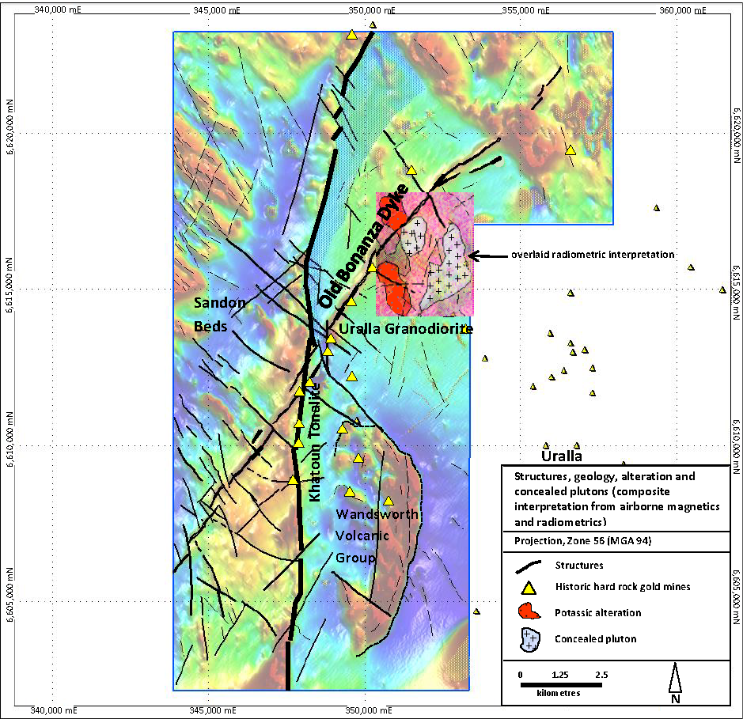

Figure 2. Structures, geology, alteration and potential concealed plutons interpreted from airborne geophysical survey (figure is a composite of magnetics with an overlay of radiometric interpretation, adapted from Gidley 2012). Radiometric overlay shows location of interpreted, fractionated concealed plutons and large areas of potassic alteration that are associated with the gold mineralisation of the Goldsworth mine.

Highly fractionated granites will have elevated K and U and, in the case of metaluminous I-types, will also have high Th. These will appear white on composite K-Th-U radiometric images (Blevin 2005).
Confirmed, Characteristic of the Rocky River-Uralla RIRGS.
- Radiometric response (three main radiometric channels K-potassium, U-Uranium and Th-Thorium; KUT-RGB), Uralla Granodiorite: The mottled, whitish appearance of this intrusive is relatively uniform across its mapped extent and suggests an elevated spectrometric response in all energy bands. The Khatoun Tonalite and the Manuka Farm Porphyritic Microtonalite are characterised by more potassic/felsic response.
- The Manuka Farm Porphyritic Microtonalite has a generally mottled appearance with contributions from all data channels. To the south, the radiometric character of the intrusive indicates a higher potassic/felsic content. West of the Manuka Farm Porphyritic Microtonalite, the Khatoun Tonalite intrusive extends from the south to the north with a mottled but slightly higher potassium channel response to that of the Manuka Farm Porphyritic Microtonalite response (Gidley 2012).

Numerous RIRGS targets have been identified but only briefly treated herein (after Gidley 2012).
A large number of major and minor lineations and probable faults have been identified. Overall, the geology is dominated by the large Uralla Granodiorite but the focus in terms of exploration opportunities is directed towards the various localised, smaller intrusives of the Uralla Plutonic Suite and the “Old Bonanza Dyke” that is evidenced by a strong magnetic lineation passing through the Rocky River-Uralla Goldfield.
- The elevated potassium responses have mapped phyllic alteration, identifying areas of both disseminated and/or structurally controlled fluid pathways, some hundreds of metres long. Some larger areas of widespread potassic alteration (up to 2km long x 1km wide) are associated with potential concealed small leucoademellite plutons intruded into the Uralla Granodiorite and developed around the Goldsworth mine and along the “Old Bonanza Dyke”.
- Magnetics and radiometrics have identified several potential blind plutons in the order of hundreds of metres in diameter. Coinciding elliptic radiometric and magnetic anomalies associated with gold-bearing structures near Frasers Find (elliptic anomalous zone approximately 570m north-south and 480m east-west) and on Rowbottom’s property (elliptic anomalous zone approximately 480m east-west and over 600m north-south) could be indicative of potential blind plutons within the Uralla Granodiorite.
- The leucoadamellites (Blackfellows Gully and Tollys Gully) have strongly elevated total count radiometric responses.
- Known gold mineralisation occurs at several locations along the “Old Bonanza Dyke” (Figures 1 and 2). This highlights the important role that structure plays in predicting the potential for fluid migration, and especially where close proximity to nearby plutons exists.
- A strong near northsouth trending lineation of magnetic anomalies appears to flank the eastern margin of the Sandon Beds and indicates potential steep sided faulted contacts with the Khatoun Tonalite and the Manuka Farm Porphyritic Microtonalite. This feature is associated with a south to north alignment of some historic mines (Martins Shaft, Gracies mine, Little Gracies mine, Hudsons prospect, Vickers prospect) and suggests a possible structural control that may have provided a plane of weakness for emplacement of intrusives. Hart (2005) notes the steep sides of small plutons are preferred geometries for enhancing fluid focusing.
- Radiating west and westnorthwest of the Khatoun Tonalite is an elevated radiometric response of an unnamed and undifferentiated granite intrusive (part of Regional Felsic Dyke Swarm and host to the gold mineralisation at Martins Shaft).

Magnetic susceptibility (Ashley, 2011, 2012, 2013; Robertson ongoing).
A wide ranging study of magnetic susceptibility (Ashely petrographic studies; Robertson, in-situ field surveys) confirmed the primarily non-magnetic characteristic of alteration and mineralisation associated with intrusives.
Martins Shaft, diamond core (petrographic studies, Ashely 2011b). The following lithologies are essentially non-magnetic, with susceptibility of <10 x 10⁻⁵ SI units.
- Porphyritic biotite-amphibole granodiorite, with slight alteration effects; very strongly hydrothermally altered (phyllic) porphyritic biotite micromonzogranite; intensely hydrothermally altered rock, possibly of felsic igneous type, with complete replacement by an assemblage of quartz and sericite, plus subordinate carbonate and sparsely disseminated arsenopyrite, stibnite, sphalerite, pyrite and rutile/anatase; very strongly hydrothermally altered lamprophyre with abundant veining. It was completely replaced by fine to medium grained ankeritic carbonate and subordinate sericite-muscovite, quartz and arsenopyrite, with a little pyrite and traces of rutile, sphalerite, pyrrhotite and tetrahedrite. A single composite aggregate is observed that contains stibnite, aurostibite and gold.

Timing: Intrusion-related deposits are coeval (± 2 m.y.) with their associated, causative pluton (Hart et al. 2004b, Hart 2005).
- Limited but significant data; some of the key plutons (Khatoun Tonalite, Uralla Granodiorite) and a felsic dyke (a component of the RFDS and associated with the gold mineralisation at Martins Shaft) have ages (SHRIMP U-Pb zircon ages and/or Rb-Sr ages) within error of each other (Chisholm, Blevin and Simpson 2014).

Elongate plutons reflect structural controls on pluton emplacement and indicate a dominant extensional direction that may be important for localizing later mineralization. RIRGS are generally well developed, surrounding small (<2km²) isolated plutons with mineralization in the intrusion and in the hornfelsed thermal aureole (Hart 2005).
- A number of gold occurrences are located immediately west of, and aligned with, the ~northsouth trending faulted? contact of the Sandon Beds with small, northsouth elongated, structurally controlled plutons (Khatoun Tonalite and Manuka Farm Porphyritic Microtonalite).

Pluton Features: Evidence of rapid fractionation and fluid exsolution indicative of volatile saturation during crystallisation at mid to high crustal levels (Blevin 2005, Hart 2005).
Confirmed, Characteristic of the Rocky River-Uralla RIRGS.
Evidence for fractionation and high volatile contents occur in varying levels of intensity throughout the Rocky River-Uralla RIRGS and comprise: Aplitic and pegmatitic dykes occur in cooling cracks of fractures throughout the Uralla Granodiorite and are probably a late stage differentiate of the melt. Non-auriferous pegmatite dykes over one metre wide traverse hundreds of metres through the Uralla Granodiorite. Medium-grained leucocratic dykes with euhedral pyrite up to 5mm in size, with small aggregates of stibnite. Miarolitic cavities present in plutons and pegmatites. Some lamprophyre dykes are associated auriferous mineralisation and mineralised phases of felsic dykes. Pearson (1975) noted some dykes are typically aplitic while others are zoned, layered and have pegmatitic textures. The zoned dykes contain tourmaline and minor topaz. The outer parts are aplitic consisting of quartz, orthoclase and minor biotite. Grain size increases towards the centre of the dykes. Hornblende in biotite granodiorite phases at Martins Shaft.

Tourmaline and tourmalinisation present e.g., at Wilsons Creek mine, Melvaines mine, Gracies mine, Hudsons prospect, and near Vickers prospect. ‘Boron-streaming’ is one of the last stages in the release of magmatic fluids. Examples include: pervasive tourmaline associated with mineralisation at Wilsons Creek mine (Robertson 2010); plumose euhedral tourmaline at Melvaines mine; zoned quartz-feldspar-tourmaline veins present as sheeted veins in the Uralla Granodiorite; aplite dykes with tourmaline beside Rocky River near Rowbottom’s House.

Core samples from Melvaines mine (Petrographic report, Ashley 2013): A porphyritic biotite microgranodiorite and a leucocratic monzogranite, grading to finer grained micromonzogranite. Porphyritic microgranodiorite characteristically contains plagioclase phenocrysts… a few late magmatic aggregates of tourmaline. The mineral proportions in the leucocratic monzogranite indicate that the rock type is strongly fractionated and probably close to granite minimum melt composition. There are textural indications that monzogranite is probably intrusive into the microgranodiorite. It is unlikely that the two igneous rocks are genetically related. There are also indications of imposed recrystallisation and deformation effects on the microgranodiorite, prior to the emplacement of the leucocratic monzogranite. The latter rock types are massive and unrecrystallised. The alteration-mineralisation characteristics of the samples, together with the close occurrence of strongly fractionated, leucocratic monzogranite veining, is interpreted to indicate that the gold mineralisation is genetically related to the emplacement of the fractionated, leucocratic granitic rocks and subsequent hydrothermal fluid evolution. The overall characteristics remain consistent with a probable intrusion-related model for the gold mineralisation, akin to other mineralised prospects in the Uralla goldfield.

DEPOSIT SCALE CHARACTERISTICS

Diagnostics geochemical characteristics.
The soil and stream sediment geochemical anomalies of IRGS can be subtle relative to other mineral systems and many explorers have misinterpreted the potential of the magnitude of key elements and hence missed out on discoveries.

Geochemical exploration case histories - TGP: Hart (2004c) studied exploration and discovery histories in the TGP and determined most deposits give surface soil anomalies of 40-100ppb Au, and C-horizon anomalies of 100-250ppb Au. He noted stream sediments with >40ppm As and >10ppb Au ... may best target favourable regions ... for Donlin Creek-Style mineralisation. Case History: Dublin Gulch, 4 million ounces of Gold. Gold values were as high as 299ppb, but are typically ~30ppb, with arsenic mostly between 300 and 1,300ppm. Ivanhoe Goldfields Ltd. made the discovery after targeting a region of anomalous soil samples (>50ppb Au) that had been identified but not followed-up by previous exploration programs.

Rocky River-Uralla RIRGS, soil/stream geochemical characteristics similar to TGP.
- Statistical analyses of hundreds of soil samples collected by Sovereign Gold are ongoing. Soil geochemical surveys identify historical mines, mineralised phyllic alteration and map gold-bearing structures.
- Comparison of response of known mineralisation in the RRUG with TGP soil and stream geochemical data: Four samples in drainage immediately around Martins Shaft were collected that returned 3x10ppb Au and 1x20ppb Au; 25ppm, 33ppm, 67ppm and 137ppm As. Mineralisation at Martins Shaft was originally exposed at surface and the four samples confirm the magnitude of significant Au and As in stream sediments for this style of mineralisation.
- A batch of 173 soil samples: 39 samples ≥10ppb Au and 109 samples ≥40ppm As; most of these values coincided with areas of alteration and/or mineralisation.
- Sovereign Gold has discovered some long (over 1km, linear gold-in-soil anomalies) coinciding with alteration and magnetic features.
- A closed spaced (50m line intervals, 5m sample spacings over grid 300m x 600m) soil survey on Rowbottom’s property, surrounding an historical mine sluiced in deeply weathered Uralla Granodiorite, discovered linear northeast trending gold anomalies associated with sheeted veins. Out of approximately 420 samples: 151 samples ≥10ppb Au including 70 samples ≥50 ppb that included 38 samples ≥100ppb and 4 samples of 1,140, 1,220, 1,280 and 2,630ppb respectively (Cozens 1985 and follow-up validation soil sampling by Sovereign Gold).

Pathfinder and source locating elements.
- As, Sb and Bi are the most useful elements to map fluid conduits and mineralisation. Sb and Bi exhibit limited dispersion and even low values (ppb) are useful in defining locations of mineralised structures. Especially effective in mapping the dominant late stage, sub-parallel northeast trending mineralised structures within the Rocky River-Uralla RIRGS.

Metal assemblages are gold-dominant with anomalous Bi, W, As, Te and/or Sb, and typically have non-economic base metal concentrations (Hart 2004c).
Confirmed, Characteristic of the Rocky River-Uralla RIRGS.
- The gold mineralisation frequently contains anomalous As, Sb, Bi (±) and W (±), but Te can often be below detection. The occurrence of trace base metal sulphides and arsenopyrite is a favourable indicator for gold mineralisation. Refer to section detailing petrographic research.

A low sulphide mineral content, mostly <5 vol%, with a reduced ore mineral assemblage that typically comprises arsenopyrite, pyrrhotite and pyrite and lacks magnetite or hematite (Hart 2005).
Confirmed, Characteristic of the Rocky River-Uralla RIRGS.
- Common, recurring characteristics of mineralisation confirmed from multielement analyses and petrographic studies of core and rock samples. Sulphide content typically mostly <5 vol% but can be up to 15-20%. Pyrrhotite rare.

The gold is fine-grained (Blevin 2005).
Confirmed, Characteristic of the Rocky River-Uralla RIRGS.
- Fine, euhedral gold crystals were reported from decomposed felsic dyke rocks in the Uralla Granodiorite (Brown et al. 1992).
- Sampling of Quaternary gravels besides the Rocky River, near Boorolong Creek: Hand panned concentrate from costean BC4 (Leu et al. 2008) yielded 9 pieces of Au: Smallest 100µmx100µm, largest 450µmx250µm; others 300µmx150µm, 250µmx200µm, 250µmx150µm, 250µmx150µm, 200µmx150µm, 150µmx50µm, 100µmx100µm. Bulk sample, Gold Screw concentrate from costean P2 (Leu 2009): Depth 4.60–5.60m, volume and mass processed were 0.63m³ and 949.5kg respectively: 210 pieces of gold, majority <500µm long; 2 particles (1x1,000µm long, 1x800µm long) and remainder grains to points.
Hand specimen and petrographic (polished thin sections) studies of visible gold.
- Petrographic studies: Gold has been observed as free gold and hosted within arsenopyrite and aurostibite.
- Martins Shaft, diamond drill core: Up to 2mm long visible gold pieces (in cluster over 6mmx3mm) within stibnite in a quartz-carbonate vein. A 4µm silvery electrum grain (rock, polished thin section, England 2011). A single composite aggregate of stibnite, aurostibite and gold, with individual gold particles up to 60µm across (Ashley 2011).
- Frasers Find, hand specimen of high grade mineralisation: Polished thin section with four grains of gold up to 180µm across (Ashley 2012). Crushed high grade quartz sulphide mineralisation: Gravity recovered several pieces of gold up to 170µm long.
- Wilsons Creek mine, polished thin section of mineralised vein: Electrum (22µmx4µm) present in association with multiple sulphides, including euhedral pyrite, galena replacing arsenopyrite, pyrrhotite, chalcopyrite, sphalerite and bismuthinite (Robertson 2010).
- Melvaines mine, diamond drill core: 5cm wide quartz sulphide vein with 1mm long visible, free gold particle. Diamond drill core: Polished thin section of vein, arsenopyrite is observed to host a single small composite aggregate of gold and galena (gold grains up to 50µm long), with a little associated chalcopyrite (Ashley 2013).
- David, T. W. E. 1887, Report on the Rocky River and Uralla Goldfield. “Gold.- The character of the Rocky River gold is rather peculiar. Most of the particles are very small, averaging about ⅛₀ inch in diameter, and are chiefly shotty, while a few are piliform (=wire-gold), or scaley. Many of the particles show definite faces of crystals, chiefly of the octahedron, proving that the fine state of division in which the gold is found is due more to its manner of crystallization in its original matrix than to mechanical disintegration by the agency of water. The coarsest fragments are found in the recent alluvials of Cabbage Tree Gully, where small nuggets are often met about ¼-inch in diameter. The gold in the recent alluvials is coarser and less water-worn than in the Tertiary.”

Alteration is variable in both style and intensity. Distal veins may have only narrow alteration selvedges. Carbonate alteration accompanying Au mineralisation may be locally well developed. Potassic (K-feldspar), sodic (albite), sericitic, greisen, skarn. Tourmalinisation is rarely developed (Blevin 2005). Areally restricted, commonly weak hydrothermal alteration; carbonic hydrothermal fluids (Hart 2005).
Confirmed, Characteristic of the Rocky River-Uralla RIRGS.
Petrographic studies and field mapping have identified all of the above in varying ratios. Mineralisation typically associated with phyllic alteration (sericite and sulphides).
- Martins Shaft-type and other mineralisation within intrusives exhibit a common alteration zonation that in hand specimen can be observed from progressive biotite and feldspar destruction (often propylitic) to increasing phyllic alteration with complete transformation to sericite-quartz-sulphide±carbonate. Sulphide deposition can be observed in biotite and hornblende undergoing alteration and release of Fe.
- The zone of hornfelsing around the Uralla Granodiorite is relatively narrow, and has caused only minor thermal recrystallisation of the country rocks (Tucker 1996a).
- As noted by Hart (2007), mineralisation can be controlled by sheeted veins and structural conduits associated with lack of broad alteration haloes, indicating depth of emplacement is associated with limited volumes of meteoric water.
- Deposition of gold mineralisation is invariably accompanied by intense sodium depletion to <0.01%.
- Alkali feldspars can be white to greenish due to phyllic alteration proximal to mineralisation.

Mineralisation from Hudsons-McCrossins mine (Petrographic report, Ashley 2011b): Intensely altered felsic dyke that retains a relict strongly porphyritic texture. Petrographically, it is estimated that it could have been a porphyritic microgranodiorite or microdiorite. This sample has experienced intense hydrothermal replacement by sericite, quartz, subordinate carbonate, disseminated pyrite and arsenopyrite and a little leucoxene. This assemblage implies hydrothermal addition of S, As, CO₂ and, possibly K, to the protolith. The geochemical results also show moderately high K and Rb, and low Na and Sr, consistent with the abundance of sericite as an alteration mineral.

Martins Shaft (Petrographic report, Ashley 2011b): It is evident that the hydrothermal fluids were somewhat acidic (e.g. sericite development), CO₂-bearing (carbonate alteration and veining), slightly reducing (arsenopyrite occurrence) and they introduced S, As, Sb, Au and base metals. The presence of significant base metal sulphides in the veins and intensely altered host rocks distinguishes the Uralla mineralisation from typical orogenic gold, or gold-antimony mineralisation (e.g. that at Hillgrove and Nundle). Hydrothermal transport of significant base metals tends to require higher fluid salinities than are found in most orogenic deposits and a source of more saline hydrothermal fluids is more plausibly from an intrusive source. It could be speculated that some of the potentially late stage, strongly fractionated, porphyritic felsic igneous rocks (e.g. forming dykes) in the Uralla region might have a role in ore genesis.

Martins Shaft, diversity of intrusives: Felsic to intermediate igneous rocks including biotite-amphibole granodiorite, porphyritic micromonzogranite, porphyritic quartz microdiorite and lamprophyre. Alteration effects, in many samples from Martins Shaft, are spatially related to fractures/veins/brecciation but in others, the alteration is pervasive. Two styles of hydrothermal alteration are recognised. One is a “distal” type, of less intensity and further away from controlling structures. This has resulted in partial replacement of plagioclase and biotite (and rarely, amphibole) and development of sericite, chlorite and carbonate, i.e. reasonably typical of propylitic alteration. The other type of alteration is more intense and commonly “proximal” to controlling structures. It is typified by destruction of feldspars and biotite, and replacement by fine grained sericite/muscovite (fuchsitic in the lamprophyres), carbonate (commonly ankeritic), quartz, minor pyrite and arsenopyrite, trace rutile/anatase, and in some samples, deposition of small amounts of other sulphide minerals (sphalerite, chalcopyrite, tetrahedrite). This type of alteration is interpreted to be a variant of phyllic type. In one sample traces of aurostibite and free (particulate) gold are observed in the vein assemblage, adjacent to stibnite aggregates.

Diamond drill core, Wilson Creek mine: Grading to brecciation, hydrothermal infill and related retrograde hydrothermal alteration. Subsequently imposed veining and breccia zones are infilled by fine grained K-feldspar (adularia) and carbonate, and the retrograde alteration has resulted in replacement of the host rock by sericite and chlorite, with trace pyrrhotite, mainly developed from the alteration of biotite.

Bannaweera prospect (Petrographic report, Ashley 2014), five drill core samples: Alteration is similar in these samples, with replacement by fine grained sericite, quartz and carbonate (e.g. ankerite), with minor pyrite and local traces of rutile, arsenopyrite and chalcopyrite. Vein contents are variations on a theme, with quartz commonly dominant, but with carbonate, sericite and pyrite. In the veining in ZK001B, there is also a trace of chalcopyrite and galena. Sample ZK0303-1 is a strongly hydrothermally altered, porphyritic micromonzogranite. It could represent an intrusive body into the metasedimentary rocks. Alteration imposed on the igneous rock appears to have changed from early development of rather coarse K-feldspar, to phyllic type, represented by strong replacement of feldspars by sericite, plus minor carbonate and pyrite, and traces of rutile, arsenopyrite, sphalerite and chalcopyrite. Sample ZK0703-1 is interpreted to represent a former fine grained …lamprophyre. The alteration and mineralisation at Bannaweera could superficially be considered as being consistent with having formed in an orogenic setting (cf. Hillgrove), with a Sb-As (-Au-Ag) geochemical association. However, the presence of igneous rocks, especially the altered porphyritic micromonzogranite, and the evident anomalism of base metals (Cu, Zn) could point to at least a partial source of the hydrothermal fluids from a crystallising granitic source.

Petrographic report (England 2011), rock samples: Hudsons prospect (S26A): Weathered quartz-white mica greisen with abundant scorodite after arsenopyrite (Au 4.74ppm, Bi 84ppm). Altered Uralla Granodiorite, Goldworth mine (S68A): Sericitised felsic porphyry. The early alteration is greisen-like. Martins Shaft (S97): 20% of <5-mm masses and stringers of <0.5-mm anhedral carbonate. Quite abundant dense clusters of <50-micron sericite. Disseminated euhedral stubby prismatic arsenopyrite (2%). 4-micron silvery electrum grain that indicates low f_{S2}. At high f_{S2}, Ag fractionates into sulphides. Martins Shaft (S103): Coarse bladed calcite, subordinate quartz and clotted sericite, with minor interstitial and clumps of columnar stibnite. The original rock was probably a felsic porphyry. The texture is probably a replacement one. Bladed calcite is common in epithermal gold deposits, though there it is usually vein fill partly or wholly replaced by quartz. The similarity does suggest that the temperature was not very high (<250°C?).

Deposit style, size, morphology and architecture.
Arrays of sheeted, low sulphide veins are the most diagnostic style of gold mineralization in RIRGS. These veins are unlike multidirectional interconnected stockworks characteristic of porphyry systems or antithetic tensional vein arrays typical of orogenic deposits (Hart 2005). Gold±Bi, As, W, Mo, Sb, Te occurs in: Single, planar, sheeted and stockwork quartz veins; disseminations in granites and skarns and as infill breccias (Blevin 2005). Solitary fracture, fissure, and shear hosted veins occur in the pluton, in the hornfels, and as far as several km from the pluton, and may fill structures that were active while creating space during pluton emplacement (Hart 2007).
Confirmed, Characteristic of the Rocky River-Uralla IRGS.
The deep emplacement of RIRGS (5-9km) can promote development of sheeted vein arrays due to the higher confining pressure inhibiting the rapid exsolution and explosive release of fluids that develops the stockworks and breccias typical of more shallowly emplaced porphyry deposits (Hart 2005).
- Gold occurs in late stage felsic and lamprophyre dykes and in sheeted quartz-sulphide veins within intrusives and metasediments, and is often associated with disseminated alteration along predominantly northeast trending structures within plutons and felsic dykes.
- Many of the gold-bearing deposits in the Rocky River-Uralla RIRGS are epizonal (Wilsons Creek mine, Hudsons-McCrossins mine, Bannaweera Structures No.1 and 2, Goldsworth mine, Gracies mine, Little Gracies mine, Hudsons prospect, Vickers prospect; Figure 1) and indicate the bulk of the system still exists at depth and it is highly probable some of these structures will be conduits directly linked at depth to a causative pluton. Mineralisation with Ag-Pb-Zn metal associations indicates a distal position in relation to causative pluton.
- Gold-bearing, low sulphide-quartz, epithermally textured, sheeted sub-parallel vein arrays are present in plutons (e.g., Uralla Granodiorite, Rowbottom’s property) and metasediments (e.g., Gracies mine and Hudsons-McCrossins mine). These can be traced over tens to hundreds of metres but near surface gold grades and vein spacing density to date have been insufficient to support economic deposits.
- Roof pendants within Uralla Granodiorite (Wandsworth Volcanics Group) and Khatoun Tonalite (Sandon Beds) host auriferous sheeted veins and indicate the present erosion level at these sites has exposed the uppermost portions of these plutons. Potential exists for gold mineralisation to be preserved within a pluton’s carapace beneath hornfelsed metasediments.
- Various late stage phases of fractionated mineralised felsic dykes and exsolved fluids have also invaded structures and at times have engulfed brecciated metasediments (e.g., Bannaweera Structures, Hudsons-McCrossins mine, Sueys Claim) or earlier dykes of the RFDS (e.g., Martins Shaft) . These can host disseminated and sheeted vein mineralisation.
- All styles of gold mineralisation described above have also been developed in a series of northeast trending structures related to a late stage extensional event (late Permian) that provided conduits for gold-bearing fluids. Some northeast structures within the Uralla Granodiorite may be related to cooling fractures temporally distinct from the dominant late stage set.
- Airborne geophysics has identified several potential small blind plutons associated with potassic alteration and gold-bearing structures.

Some Specific Deposit Styles of the Rocky River-Uralla RIRGS: Martins Shaft, Goldsworth Mine, Frasers Find, The Bannaweera Structures, Melvaines Mine.

Martins Shaft

Disseminated and sheeted vein gold mineralisation within altered predominantly felsic (intrusive phases and host dyke) and lesser lamprophyre dykes. It is hosted in a late stage northeast trending structure cutting a dyke of the RFDS that is in contact (faulted?) with the small, elongate pluton of the Khatoun Tonalite.

The Martins Shaft mineralised structure has now been traced from outcrop to a depth of 217.60m and remains open (Figure 4). It strikes northeast and dips 75⁰ southeast; true width of mineralisation ranges from 10-27m. The dyke of the RFDS has acted as a brittle host for magmatic fluids. It is clear, from the presence of gold mineralisation and associated alteration, that igneous textures are very conducive to the permeation/dissemination of gold-bearing fluids. Potential exists for multiple Martins Shaft-type deposits, of similar and larger size, within the large RIRGS. Associated sulphide mineralisation consists of pyrite, arsenopyrite and stibnite. Analytical data confirms gold mineralisation is associated with sodium depletion and phyllic alteration.

Some of the better, wide and high gold grade diamond drill hole intersections include (Figure 3):
- SGRDD002: 22m @ 3.28g/t Au from 18-40m downhole, including 10m @ 6.06g/t Au gold from 27-37m downhole and 2m @ 18.85g/t Au from 35-37m downhole.
- SGRDD004: 18m @ 3.51 g/t Au from 52-70m downhole, including 7m @ 7.47g/t Au from 57-64m downhole and 1m @ 19.60g/t Au from 58-59m downhole.
- SGRDD014: 20m @ 2.34g/t Au from 16-36m downhole, including 15m @ 3.05g/t Au from 19-34m downhole, including 4m @ 7.77g/t Au from 21-25m downhole and 1m @ 15.40g/t Au from 24-25m downhole. Also 5m @ 0.32%/t Sb from 24-29m downhole.

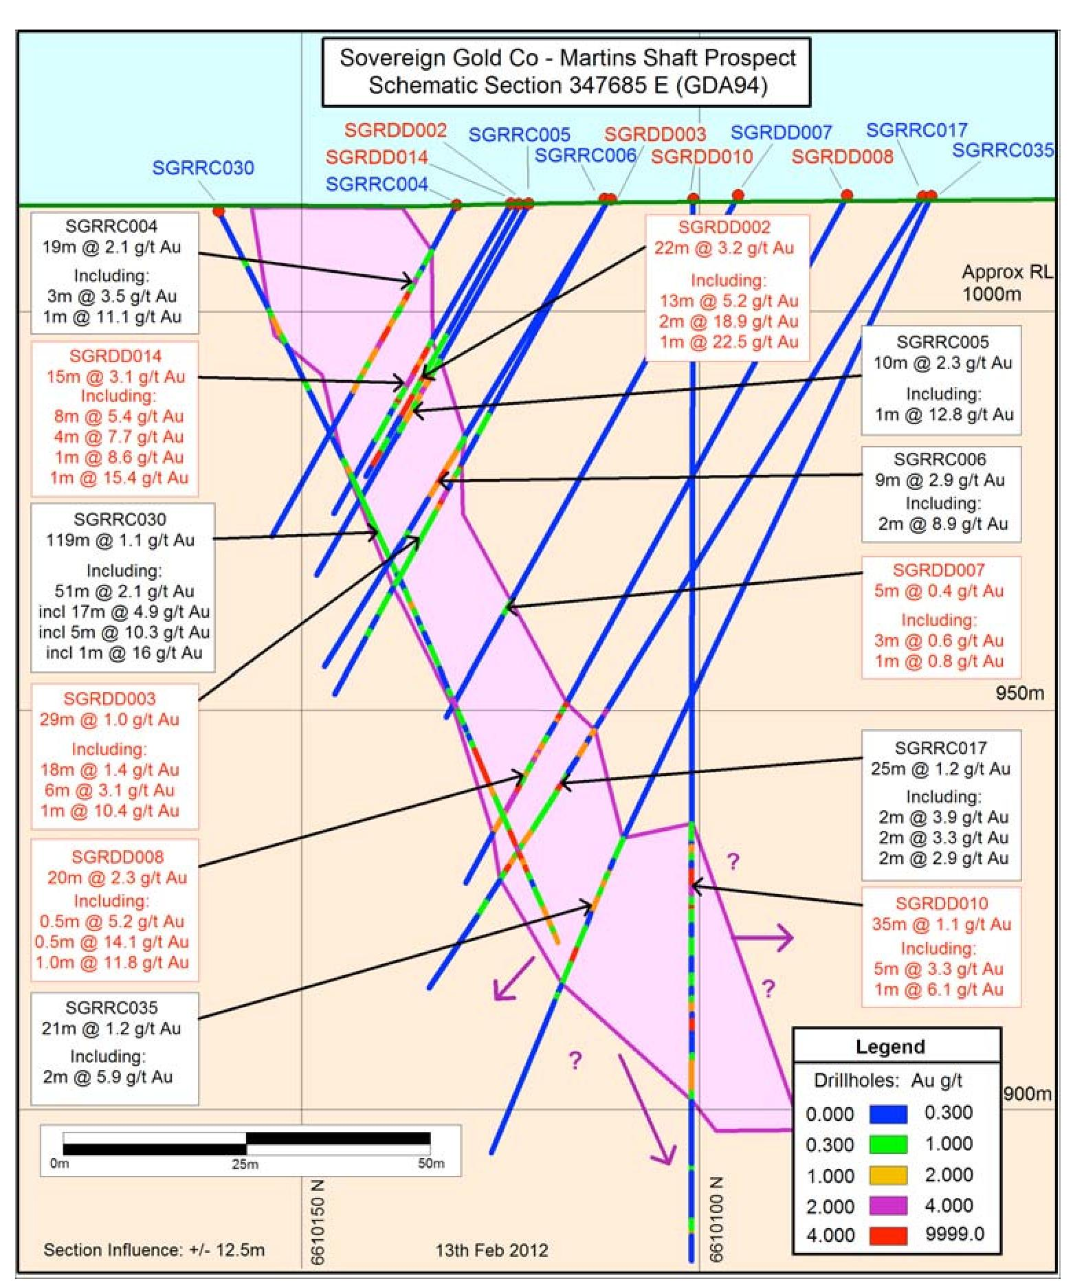

Figure 3. Martins Shaft: Gold intersections, diamond and reverse circulation drill holes, schematic section.
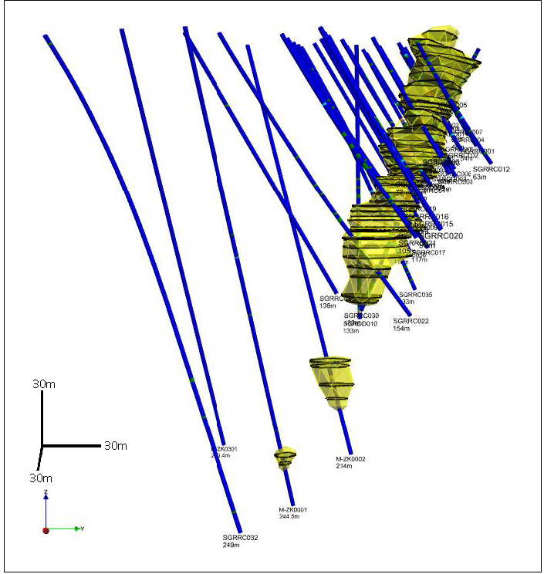

Figure 4. Martins Shaft: 3D wireframe of mineralised structure and drill hole plots, looking west
(modelled to +0.30g/t Au to map morphology of the gold-bearing alteration shell).

The Goldsworth Mine

Situated along a jogged portion of an extensive northeast trending structure (“Old Bonanza Dyke”, magnetic linear, Figures 1 and 2) within the Uralla Granodiorite. Gold mineralisation is primarily associated with sheeted quartz-sulphide veins and disseminated phyllic alteration (arsenopyrite, pyrite, green sericite and quartz). Some dykes were encountered in drill holes but most mineralisation is associated with veining and alteration. Mineralisation is present for 570m along the strike of the magnetic linear and to a depth of 108m downhole (open in all directions).

Drilling encountered (Figure 5) narrow zones of gold mineralisation ranging from 1-4m wide (down-hole width). The widest intercept was 4m at 1.17g/t Au, including 1m at 2.7g/t Au (SGRRC054) from 101-105m downhole. The highest grade was 1m at 5.14g/t Au from 103-104m from an interval of 3m @ 2.14g/t Au from 102-105m downhole (SGRRC065). In addition to the main structure, two other parallel, narrow intervals of low grade gold mineralised structures were recorded in some holes.

The magnetic linear has defined a significant structure that has channelled mineralising fluids. It hosts several historic gold mines and some recently discovered soil and rock chip anomalies. There are untested targets over many kilometres that are either on/or immediately adjacent to this structure.

The airborne geophysical survey has identified potential small, concealed plutons linked with large areas of potassic alteration that are associated with the gold mineralisation of the Goldsworth mine and the jogging of the magnetic linear (Figure 2).

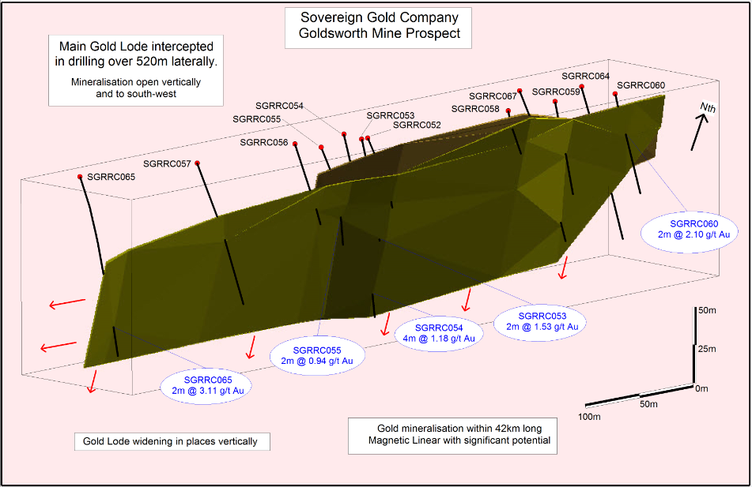

Figure 5. The Goldsworth mine area: 3D wireframe of mineralised structure and drill hole plots - gold mineralisation potential present over hundreds of metres of strike.

Frasers Find

High grade gold mineralisation is hosted in narrow vein structures within the Uralla Granodiorite. Drilling has traced the main narrow vein structure along 315m of strike (northeast) and costeaning has exposed it for 380m along strike (open along strike and at depth). The mapped gold mineralisation within this structure extends to the sub-circular geophysical anomaly that potentially represents the alteration halo above a small, concealed pluton (Figure 6) that has released fluids into the surrounding rocks via fractures. The sub-circular anomaly extends beneath the presumed steeply dipping contact of the Khatoun Tonalite and the Uralla Granodiorite. An unrecorded historical mine discovered by Sovereign Gold (Diggers Shaft) lies on an interpreted fracture radial to the blind intrusive. This mine has sheeted vein mineralisation within a roof pendant of thermally altered Sandon Beds that overlies the Khatoun Tonalite.
.
Some of the better, narrow, high gold grade diamond drill hole intersections include:
- SGRDD033: 25.1g/t Au over 0.11m within a total intercept of 19.2g/t Au over 0.16m from 23.84-24m downhole.
- SGRDD023: 19.1 g/t Au (14.25 g/t Au duplicate), 141 g/t Ag and 0.75% Pb over 0.6m (~40% length recovery) from 11.1-11.7m downhole.
- SGRDD029: 5.45 g/t Au over 0.25m from 27–27.25m downhole, including a narrow high grade sulphide-dominated portion of 10g/t Au (8.78 g/t Au duplicate), 316g/t Ag, 1.98% Pb and 0.35% Zn over 0.13m.

Shallow drilling has intersected mineralisation with high Ag, Pb and Zn that represents the distal, low temperature end of the auriferous fluid plumbing. This high level metallogenic association also indicates the entire system is preserved at depth.

Apart from the main high grade narrow mineralised interval, a broader mineralised zone, as defined by sulphide alteration veins with anomalous gold, was present in each hole and widened to the southwest towards the predicted source of the gold. Diamond drill hole SGRDD033, closest to the potential causative blind pluton, encountered intermittent narrow sulphide-bearing alteration veins with anomalous gold over 27.35m downhole (from 11.75-39.1m). This hole also contained the highest gold grade (25.1 g/t). As extrapolated, increasing hydraulic fracturing from magmatic hydrothermal fluids appears to be developing proximal to the potential concealed pluton.

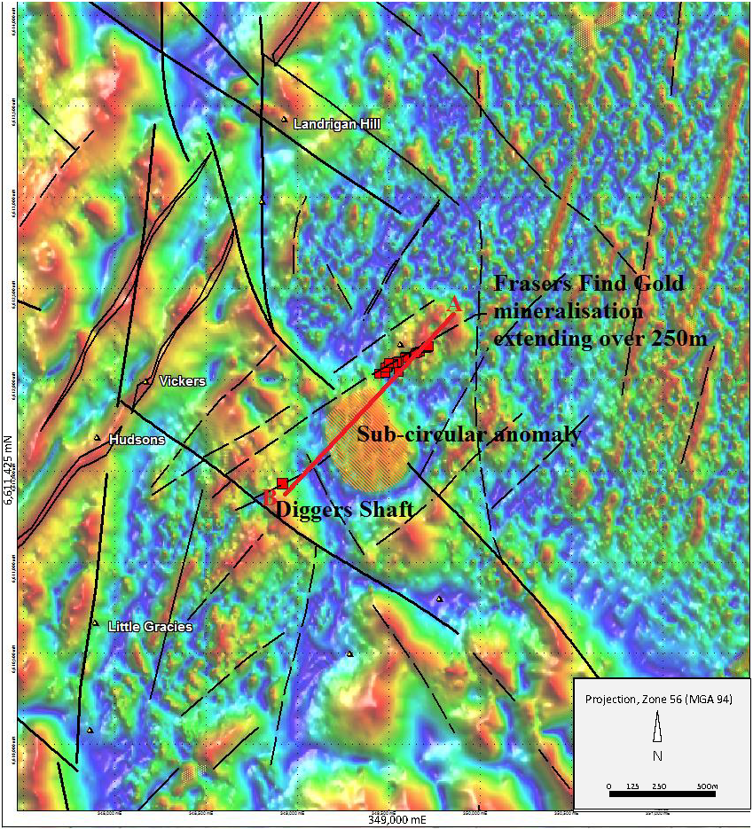

Figure 6. Sub-circular magnetic anomaly and associated structures hosting the gold mineralisation of Frasers Find and Diggers Shaft.
The Bannaweera Structures

Comprise sheeted veins, disseminated mineralisation and dyking hosted in metasediments and controlled by parallel northeast trending structures that the cut multiple northwest trending felsic dykes of the RFDS. No previous historic mines or exploration pits. Greenfields mineralisation discovered through combination of airborne geophysics, soil sampling, mapping of alteration and lithology.

Several northeast trending gold-bearing mineralised structures including the 1.55km long No. 1 Bannaweera Structure and sub-parallel No. 2 Bannaweera Structure, traced for ~1,000m and situated around 1,100m northwest of the No. 1 Bannaweera Structure.

Drilling confirmed the entire 1.55km length of the No. 1 Bannaweera Structure is mineralised and established it is best developed along 274m of strike in the southwest portion of the structure. Martins Shaft-type mineralisation has been intersected in the felsic and lamprophyre dykes associated with brecciation and silica-sulphide flooding

No. 1 Bannaweera Structure (1.55km long): Drilling has located both high grade (up to 12.35g/t Au over 0.5m downhole) and wide (13.90m @ 1.45g/t Au, 11.88g/t Ag from 13.79-27.69m downhole) gold mineralisation at shallow depths, indicating potential for a small open-cut operation. Gold mineralisation confirmed to 190.6m downhole and remains open.

Some of the better gold grade diamond drill hole intersections include:
- SGRDD036: 2.72g/t Au over 4.85m from 7-11.85m downhole, including 7.8g/t Au over 1m and 12.35 g/t Au over 0.5m.
- ZK0701: 1.45g/t Au, 11.8g/t Ag over 13.9m from 13.79-27.69m downhole, including 2.34m @ 3.02g/t Au from 14.56-16.90m.
- SGRDD039: 1.07g/t Au over 12m from 3-15m downhole, including 3.15m @ 2.5/t Au from 10.70-13.85m, including 0.6m @ 4.93/t Au from 10.70-11.30m.
- ZK0901: 10.35m @ 71.86g/t Ag from 15.85-26.20m downhole, including 5.48m @ 1.24g/t Au, 57.39g/t Ag from 14.62-20.10m, including 0.80m @ 3.08g/t Au, 72.10g/t Ag from 15.85-16.65m.

Melvaines Mine

Melvaines mine is associated with strongly fractionated leucocratic monzogranite. Wide spaced sheeted veining is developed including a 5-10cm wide quartz vein with free gold (observed in drill core) and sulphides (pyrite, arsenopyrite). The alteration-mineralisation is interpreted (Ashley 2013) to indicate that the gold mineralisation is genetically related to the emplacement of the fractionated, leucocratic granitic rocks and subsequent hydrothermal fluid evolution.

Conclusions

The Rocky River-Uralla Goldfield has multiple characteristics distinctly diagnostic of Reduced Intrusion-Related Gold Systems. Gold mineralisation is associated with late stage plutons and dykes derived from melts generated over a relatively short interval of geologic time. They are amongst the final products of a much longer time interval of regional magmatism.

Gold mineralisation is hosted by dykes (predominately felsic and lesser lamprophyric) and sheeted quartz-sulphide veins emplaced within intrusives and metasediments. It is predominantly controlled by northeast trending structures related to a late stage extensional event (late Permian) that provided conduits for exsolved gold-bearing fluids. Portions of these system-wide, predominantly epizonal structures should provide vectors to the main feeder conduits of potential small, concealed causative pluton(s). Airborne geophysics, in combination with other diagnostic properties, has identified locations for drill targets. A priority area surrounds the Goldsworth mine where magnetics and radiometrics have mapped jogged structures associated with broad areas of potassic alteration derived from interpreted, fractionated blind plutons. The large scale of this relatively underexplored system supports the discovery of an economic gold deposit.

The diagnostic characteristics defined above provide a template to identify similar auriferous systems within the granite belts of the New England Orogen.

Acknowledgements

Shareholders and the geology team (Richard Robertson, Dr. Yamei Wang and Kevin Chard) of Sovereign Gold Company Limited have supported a considerable investment into research defining the mineral system hosting the Rocky River-Uralla Goldfield. The advancement of knowledge in RIRGS diagnostic characteristics defined herein has also developed through collaboration with Dr. Phil Blevin, Dr. Paul Ashley, Dr. Peter Downes, Dr. David Forster and Peter Gidley. Dr. Dick Glen provided data on the new model proposed for the Macquarie Volcanic Belt. The project has benefited substantially from decades of dedicated research by eminent Australian Geoscientists. Key components essential to this synthesis have been derived by Geoscientists from Geological Exploration Technology Institute of Jiangsu Province, China including Yu Zhengyou, Professor Jiandong Liu, Dr. Mingzuan Xu, Dr. Jumin Du, Qian Wang, Guo Donglian, Weidong Cai, Xudong Ni, Feng Cheng, Wu Yongqian, Zhang Dianji, Tai Shengsu and Liwei Min.

Cited References

Ashley, P.M. 2010. Petrographic Report on Twenty Rock Samples from the Uralla Area, Northeastern New South Wales
Ashley, P.M. 2011a. Petrographic Report on a Sample from the Halls Peak Area and a Sample from the Uralla Area, Northeastern New South Wales.
Ashley, P.M. 2011b. Petrographic Report on Eighteen Drill Core Samples from the Uralla Area, Northeastern New South Wales.
Ashley, P.M. 2012. Petrographic Report on Twenty-one Rock Samples from the Uralla Area, Northeastern New South Wales.
Ashley, P.M. 2014. Petrographic Report on Five Drill Core and Five Rock Samples from the Uralla and Armidale Regions and One Drill Core Sample from Halls Peak, Northern New South Wales.
Blevin, P.L, Chappell. B.W. and Allen, C.M. 1996. Intrusive metallogenic provinces in eastern Australia based on granite source and composition. Transactions of the Royal Society of Edinburgh: Earth Sciences 87: pp.281–290.
Blevin, P.L. 2004. Redox and compositional parameters for interpreting the granitoid metallogeny of eastern Australia: Implications for gold-rich ore systems. Resource Geology 54, pp.241–252.
Blevin, P.L. 2005. Intrusion Related Gold Deposits. PetroChem Consultants Pty. Ltd., Geoscience Australia.
Brown, R. E. 2003. Peel South Exploration NSW geophysics – interpretation of new data for exploration and geological investigations in the western New England area of New South Wales. Geological Survey of New South Wales, Quarterly Notes, 114.
Brown, R.E., Brownlow, J.W. and Krynen, J.P. 1992. Manilla-Narrabri 1:250,000 Metallogenic Map SH/56-9, SH/55-12: Metallogenic Study and Mineral Deposit Data Sheets. Geological Survey of New South Wales, 319pp.
Bryant, C.J., Chappell, B.W. and Blevin, P.L. 2003. Granites of the Southern New England Orogen. In: Blevin, P.L., Jones, M. and Chappell, B.W. (eds.) The Ishihara Symposium: Granites and Associated Metallogenesis, GEMOC, Macquarie University, Geoscience Australia Record, 2003/14.
Chisholm, E.I., Blevin, P.L. and Simpson, C.J. 2014. New SHRIMP U–Pb zircon ages from the New England Orogen, New South Wales: July 2010–June 2012. Geoscience Australia Record, 2014/13.
Cozens, G. 1985. Report on E.L. 2387 for T. R. Low & Associates. Geological Survey of New South Wales File GS1985/239 (R00010009).
David, T.W.E. 1887. Report on the Rocky River and Uralla Goldfield. Department of Mines New South Wales, Annual Report for 1886, pp.153-158.
England, R.N. 2011. Petrographic Notes for 26 Samples from the Rocky River-Uralla Goldfield.
Glen, R.A. 2005. The Tasmanides of Eastern Australia. In: Vaughan, A.P.M., et al. (Ed.), Terrane Processes at the Margins of Gondwana. Geological Society, London, Special Publications, 246, pp.23–96.
Glen, R.A., Quinn, C.D. and Cooke, D.R. 2012. The Macquarie Arc, Lachlan Orogen, New South Wales: its evolution, tectonic setting and mineral deposits. Episodes, 35, pp.177-186.
Hart, C.J.R., Goldfarb, R.J., Lewis, L.L., and Mair, J.L. 2004a. The Northern Cordillera Mid-Cretaceous Plutonic Province: Ilmenite/magnetite-series granitoids and intrusion-related mineralisation: Resource Geology, v. 54, n. 3, pp. 253–280.
Hart, C.J.R., Villeneuve, M.E., Mair, J.L., Goldfarb, R.J., Selby, D. Creaser R.A. and Wijns, C. 2004b. Comparative U–Pb, Re–Os and Ar–Ar geochronology of mineralizing plutons in Yukon and Alaska. SEG 2004 Predictive Mineral Discovery Under Cover, Extended Abstract, J. Muhling et al. (eds.), Perth, Australia, pp. 347-349.
Hart, C.J.R. 2004c. Mid-Cretaceous Magmatic Evolution and Intrusion-Related Metallogeny of the Tintina Gold Province, Yukon and Alaska, Thesis Presented for the Degree of Doctor of Philosophy, The University of Western Australia.
Hart, C.J.R. 2005. Classifying, Distinguishing and Exploring for Intrusion-Related Gold Systems. Canadian Institute on Mining Special Issue Newsletter, 87.
Hart, C.J.R. 2007. Mineral deposits of Canada: a synthesis of major deposit-types, district metallogeny, the evolution of geological provinces, and exploration methods; by Goodfellow, W D (ed.); Geological Association of Canada, Mineral Deposits Division, Special Publication no. 5, pp.95-112.
Hee, R. 2005. EL 5889 Mt Adrah, NSW, Final & Annual Report, Golden Cross Operations Pty. Ltd., Report GCO401. Geological Survey of New South Wales File GS2005/289.
Hooper, B., Ashley P. M. and Shields, P. 2006. The Hillgrove Gold-Antimony-Tungsten District, NSW, Australia. SMEDG, Australian Institute of Geoscientists, Mines and Wines Conference.
Lang, J.R., Baker, T., Hart, C.J.R., and Mortensen, J.K. 2000. An exploration model for intrusion-related gold systems. Society of Economic Geologists Newsletter, 40, pp.6-14.
Leu, M.R., and Murphy, J. 2008. Exploration Licence 6483, Annual Report for Period Ending 20th November 2008. Geological Survey of New South Wales Restricted Files.
Leu, M.R. 2009. Exploration Licence 6483, Annual Report for Period Ending 20th November 2009. Geological Survey of New South Wales Restricted Files.
Leu, M.R., Robertson, R.A. and Wang, Y. 2011–2014. Exploration Licence 6483, Annual Reports for Period Ending 20th November. Geological Survey of New South Wales Restricted Files.
Mackay, D. F. 1953. The Rocky River Goldfield 1851-1857. MA thesis, Monash University, Melbourne (unpubl.).
Markham, N.L. 1975. Gold deposits of the New England Fold Belt. Geological Survey of New South Wales, Report GS1975/378.
Pearson, D.F. 1975. The Rocky River gold field. Geology III project, University of New England, Armidale (unpubl.).
Phillips, G., Landenberger, B. and Belousova, E.A. 2011. Building the New England Batholith, eastern Australia-Linking granite petrogenesis with geodynamic setting using Hf isotopes in zircon. Lithos, 122, No. 1-2, (2011), pp.1-12.
Quinn, C.D., Percival I.G., Glen, R.A. and Xiao, W.-J. 2014. Ordovician marginal basin evolution near the palaeo-Pacific east Gondwana margin, Australia. Journal of the Geological Society, London.
Robertson, R.A. 2010. The Mineralisation and Characterisation of the Wilsons Creek Au Deposit, West of Uralla, NSW, Australia, as an Intrusion-Related Gold Deposit. In: Buckman S., Blevin P.L. (eds.) 2010, New England Orogen Conference 2010. University of New England.
Shaw, S.E. and Flood, R.H. 1981. The New England Batholith, Eastern Australia: Geochemical Variations in Time and Space, Journal of Geophysical Research, 86(B11), pp.10,530–10,544.
Thompson, J.F.H. and Newberry, R.J. 2000. Gold deposits related to reduced granitic intrusions. Society of Economic Geologists, Reviews 13, pp.377–400.
Tucker, R.M. 1996a. EL 4795 – Uralla. First Annual and Final Report for the Period 27 February 1995 to 19 July 1996, Cyprus Gold Australia Corporation Report No. 897. Geological Survey of New South Wales File GS1996/494.
Tucker, R.M. 1996b. EL 4886 – Uralla North. First and Final Report for the Period 18 August 1995 to 19 July 1996, Cyprus Gold Australia Corporation Report No. 898. Geological Survey of New South Wales File GS1997/030.

